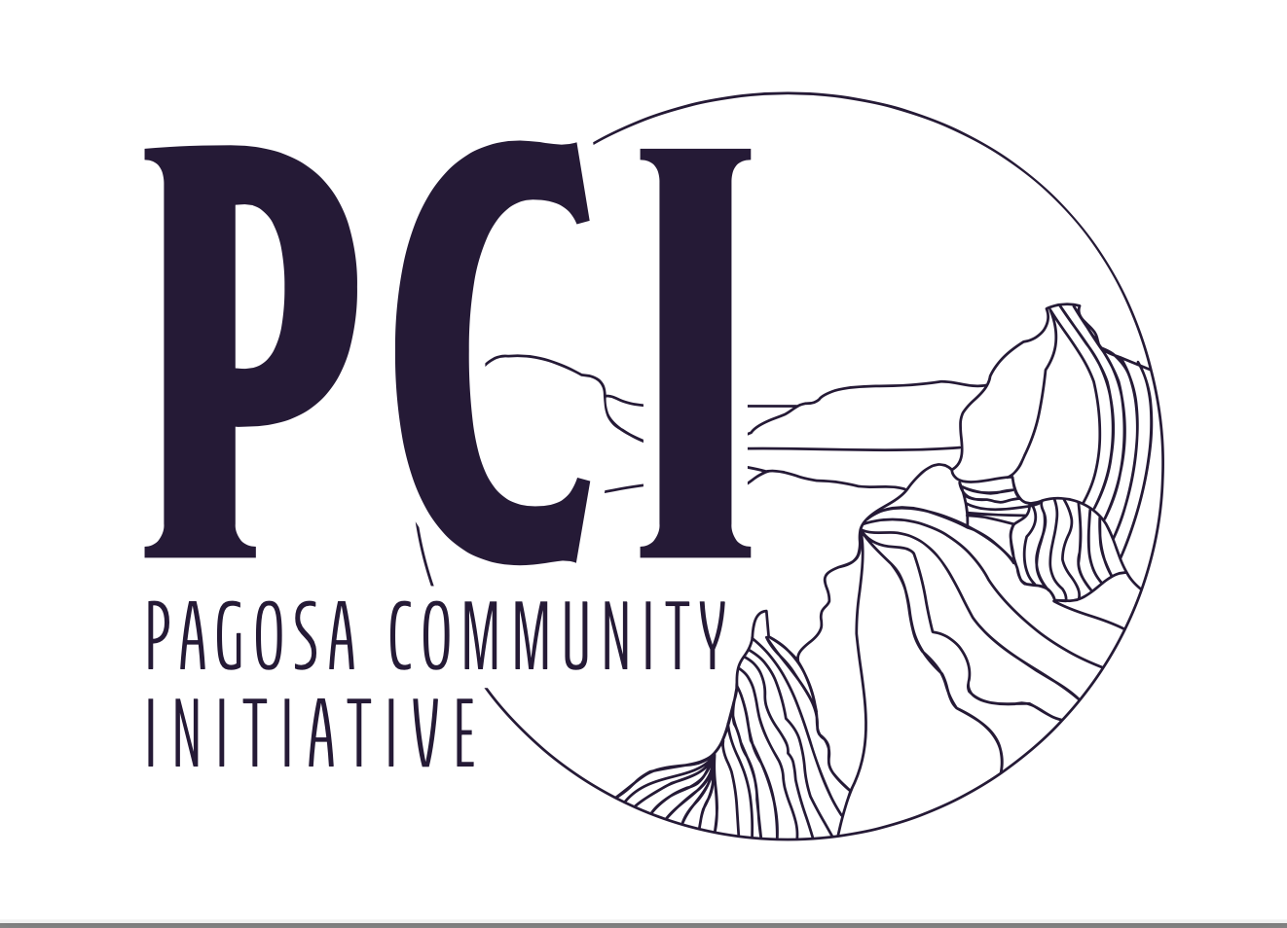

Summer Camp FAQ

Will there be scholarship options?
Yes. Scholarships will be available for the G.E.T. Wild Child Camp. Please note that scholarship and reduced-price spots are very limited due to our camp’s small size. Families must complete a scholarship application, and awards will be based on demonstrated need.

Is there a waitlist for full camp weeks?
Yes. We maintain a waitlist for full camp weeks and often fill openings from the waitlist. If a week is full and you would like to add your child, please email:
youth@pagosacommunityinitiative.org

How far in advance should we register? Do camp weeks fill quickly?
Enrollment varies depending on school schedules, other camps, and family plans. Because of this, we cannot guarantee availability or offer drop-in care. We encourage families to register as early as possible. If spots open, we may contact waitlisted families the weekend prior to camp.

Can we choose specific weeks, or is this a full-summer commitment?
Camp registration is flexible and offered on a week-by-week basis. Camp runs Monday through Thursday each week and is not a full-summer commitment. Each week includes a variety of off-site adventures such as hiking trails, parks, historical sites, and other community locations.

What is the age range? Are campers grouped by age?
We accept campers who have completed Kindergarten through 8th grade. Campers must have completed at least one full year of Kindergarten and be fully potty trained.
Camp groups are mixed-age, which helps build leadership, mentorship, and community. Some hikes and activities can be physically demanding, and younger campers may require additional support. Staff carefully monitor all campers to ensure their safety and comfort.
We are also exploring middle school-only camp weeks in the future. More information will be shared as it becomes available.

Who leads the camp? What is the camper-to-staff ratio?
Camp is led by our Youth Programming Director, who oversees planning and attends most camp days. The team also includes:
- Additional adult staff (including designated drivers)
- High school leaders who have experience working with PCI youth
Our typical camper-to-staff ratio is approximately 6:1, allowing for strong supervision and meaningful engagement.

Where does camp take place?
Base camp locations include:
- Session 1: Pagosa Springs Elementary School
- Session 2 (G.E.T. Wild Child): Pagosa Springs High School
Campers begin their day at base camp with free play, art projects, and group activities. Midday, campers travel to adventure locations such as:
- Parks
- Hiking trails
- Swimming pools and shallow river areas
- Hot springs pools
- Historical sites
- Geothermal grow domes
Campers typically return to base camp by afternoon pickup. If you need early pickup, please coordinate with staff at drop-off.

How do I communicate with camp staff during the day?
We primarily use the Brightwheel app for communication. Please note that some adventure locations are outside of cell service, so responses may be delayed.

Can missed camp days be made up?
No. Missed camp days cannot be transferred or made up during other camp weeks.

What should my child bring each day?
Please send your child with:
- Cold lunch
- Extra snacks (PCI provides 2 snacks daily)
- Water bottle
- Sunscreen (applied before camp and packed for reapplication)
- Hat
- Weather-appropriate clothing and footwear
- Change of clothes
- Swimsuit and towel (recommended due to frequent water activities)
PCI provides two daily snacks and limited backup sunscreen.

How do I complete required paperwork?
All registration and required forms are completed through Brightwheel. Families will receive instructions via email after registering.
Please ensure the following are completed before your child’s first day:
- Emergency contact information
- Medical and allergy information
- Required waivers and permission forms
All forms must be completed and signed prior to your child attending camp.
For assistance, contact:
youth@pagosacommunityinitiative.org

Does my child need to be a strong swimmer?
No. We provide life vests and require their use when appropriate. Staff carefully select safe water locations and supervise campers closely based on their age, comfort level, and swimming ability.

Are there volunteer opportunities for adults?
At this time, we are not offering volunteer opportunities. As a Family Resource Center, PCI must follow strict intake and background check procedures for all staff and volunteers. We are working to develop volunteer processes for the future but currently have limitations due to transportation, space, and safety requirements.

